
JAWAHARLAL NEHRU TECHNOLOGICAL UNIVERSITY VIZIANAGARAM
VIZIANAGARAM – 535003
ANDHRA PRADESH
ELECTRICITY USAGE TRACKER
By
A.MAHESWARULU
(Regd. No. 24VV1A1204)
Under the supervision of
MRS. MADHUMITA CHANDA
Department of Information Technology
JNTUGV, Vizianagaram
Academic Year: 2026–2027
CONTENTS
- Introduction ................................................................................................................ 3
- Project Overview and Requirements .......................................................................... 4
- Project Architecture and Structure ............................................................................. 6
- Flutter Development Environment Setup ................................................................... 8
- Dart Programming Fundamentals Used in the Project ............................................. 11
- Creating and Configuring the Flutter Project ........................................................... 13
- Electricity Usage Tracker – Case Study ................................................................... 14
- User Authentication and Profile Management ......................................................... 16
- Meter Reading Management .................................................................................... 18
- Consumption and Bill Estimation .......................................................................... 20
- Usage Analytics and History .................................................................................. 22
- Alerts and EnergySaving Guidance ...................................................................... 24
- Exploring Flutter Widgets in the Project ................................................................ 26
- Responsive UI Design ............................................................................................ 28
- Navigation Between Screens .................................................................................. 30
- Stateful and Stateless Widgets ................................................................................31
- State Management .................................................................................................. 32
- Custom Widgets and Styling .................................................................................. 33
- Forms and Validation ............................................................................................. 35
- Local Data Storage with SQLite .............................................................................37
- Database and Data Models ..................................................................................... 39
- Animations and User Experience ........................................................................... 41
- Testing and Debugging ...........................................................................................42
- Application Workflow ............................................................................................ 44
- Security and Data Validation ..................................................................................49
- Conclusion .............................................................................................................. 50
1. Introduction
Flutter is an opensource UI framework developed by Google for building crossplatform applications from a single codebase. Flutter uses the Dart programming language and provides a widgetbased approach for creating interactive mobile interfaces.
The Electricity Usage Tracker is a Flutter application that helps a user record meter readings, calculate units consumed and estimated bills, review usage history, and understand consumption patterns. The application stores its data locally and presents the information through a responsive interface.
Advantages of Flutter
- Crossplatform development from a common codebase.
- Hot reload for faster interface development.
- A large collection of customizable Material widgets.
Dart Language
Dart is objectoriented, strongly typed, and supports asynchronous programming through Future,
async, and await. These features are used while reading and writing SQLite data and while updating
screens after user actions.
Key Flutter Features Used in This Project
- Widgetbased screens for dashboards, forms, cards, charts, and lists.
- Stateful widgets for readings, theme selection, and changing usage data.
- Navigation between authentication, dashboard, history, analytics, and profile screens.
2. Project Overview and Requirements
The Electricity Usage Tracker is a mobile application for maintaining electricity meter records. A user
can register, sign in, add readings, estimate a bill, review past consumption, inspect monthly charts,
and configure a tariff value used in calculations.
Problem Statement
Electricity consumption is often recorded manually, which makes it difficult to compare monthly usage
or estimate a bill before it arrives. Users need a simple way to preserve meter readings, calculate units
and charges consistently, and identify highconsumption periods.
Main Objectives
- Provide account registration, login, and profile management.
- Allow users to add, view, and delete meter readings.
- Calculate consumed units from consecutive readings.
- Estimate electricity bills using a configurable tariff.
- Present usage history and monthly analytics.
- Provide inapp highusage alerts and energysaving guidance.
- Persist user data and readings locally using SQLite.
- Support light and dark themes with a responsive interface.
Application Scope
The application is a singledevice tracker. It does not connect to an electricity provider, read a smart meter, synchronise data to a cloud service, or send scheduled notifications outside the application.

2. Project Overview and Requireme |  | nts
Functional Requirements
Module | Requirement
Authentication | Registration, login, log | out, duplicateemail checks, and form validation.
Profile | View and update the us | er name email address and electricity tariff
 |  | , , .
Readings | Add, list, and delete me | ter readings for the signedin user.
Calculation | Compute units from co tariff. | nsecutive readings and calculate the bill from the
Bill Estimate | Estimate a bill from a userentered number of units without saving a reading.
Analytics | Display monthly usage and bill charts, averages, and a highestusage insight.
Alerts | Show highusage warnings, monthly reminders, and energysaving tips.
Storage | Persist users, readings, and settings locally with SQLite.
NonFunctional Requirements
- Usability: clear forms, readable cards, and straightforward navigation.
- Performance: database work is asynchronous and does not block the interface.
- Maintainability: screens, models, services, and theme code are separated.
- Scalability: additional modules can be added without rebuilding every screen.
- Portability: the interface adapts to different mobile screen sizes.
3. Project Architecture and Structure
The application follows a modular Flutter structure. Interface code is separated from models, database
access, and shared theme configuration so that each part can be maintained independently.
Project Directory
electricity_usage_tracker/
├── lib/
│ | ├── main.dart
│ | ├── database/
│ | │ └── database_helper.dart
│ | ├── models/
│ | │ └── electricity_reading.dart
│ | ├── services/
│ | │ └── database_service.dart
│ | ├── screens/
│ | │ ├── splash_screen.dart
│ | │ ├── landing_screen.dart
│ | │ ├── login_screen.dart
│ | │ ├── register_screen.dart
│ | │ ├── dashboard_screen.dart
│ | │ ├── add_reading_screen.dart
│ | │ ├── bill_estimate_screen.dart
│ | │ ├── usage_history_screen.dart
│ | │ ├── analytics_screen.dart
│ | │ ├── alerts_screen.dart
│ | │ ├── profile_screen.dart
│ | │ └── personal_information_screen.dart
│ | └── theme/
│ | ├── app_theme.dart
│ | └── theme_controller.dart
├── android/
├── assets/
├── test/
└── pubspec.yaml
3. Project Architecture and Structure Description of Project Modules

Directory | Purpose
lib/ | Contains the Dart source | code for the application.
database/ | Defines the local SQLite | connection and table creation logic.
models/ | Represents an electricity | reading and converts database rows into objects.
services/ | Provides asynchronous C | RUD operations and tariff settings.
screens/ | Contains complete pagel | evel interfaces and user interactions.
theme/ | Defines the light and dark | visual styles and persisted theme selection.
assets/ | Stores static application r | esources declared in pubspec.yaml.
test/ | Contains automated tests; | the current file is the default Flutter template test.
ubs ec aml | Declares Flutter de ende | ncies assets and roject confi uration
p p .y | p | , , p g .
Architecture Flow
Flutter Widgets and Screens ↓
Local UI State and ThemeController
↓
DatabaseHelper / DatabaseService
↓
sqflite SQLite Database ↓
users, readings and settings tables
4. Flutter Development Environment Setup
Flutter SDK Installation
- Download the stable Flutter SDK from the official Flutter website.
- Extract the SDK to a location such as C:\src\flutter.
- Add C:\src\flutter\bin to the Windows PATH.
- Open a new terminal and run flutter version.
- Run flutter doctor to identify missing components.
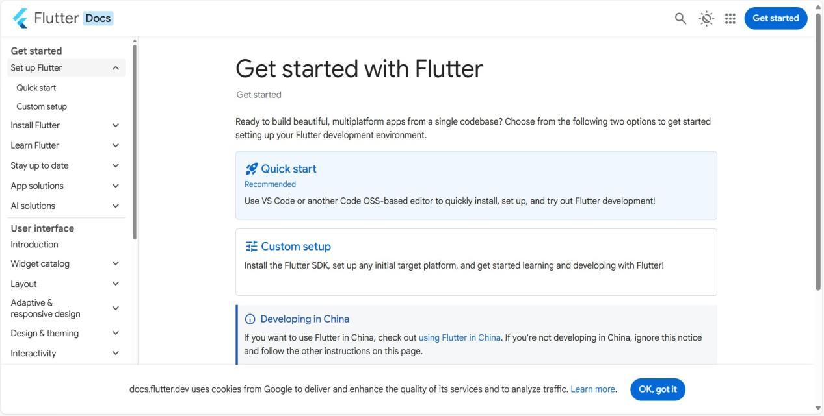
Flutter SDK installation and toolchain verification
Android Toolchain Without Android Studio
The project can be developed with Visual Studio Code and the Android commandline tools. Android
Studio is not required as the code editor.
- Install the Android SDK commandline tools.
- Configure the Android SDK path and platform tools.
- Accept the licences with flutter doctor androidlicenses.
- Run flutter doctor and confirm the Android toolchain checks.
- Use a connected device or emulator when running the application.
4. Flutter Development Environment Setup
Visual Studio Code
- Install Visual Studio Code.
- Open the Extensions panel with Ctrl + Shift + X.
- Install the Flutter extension; Dart is installed as a dependency.
- Open the project folder in VS Code.
- Use the integrated terminal for Flutter commands and debugging.
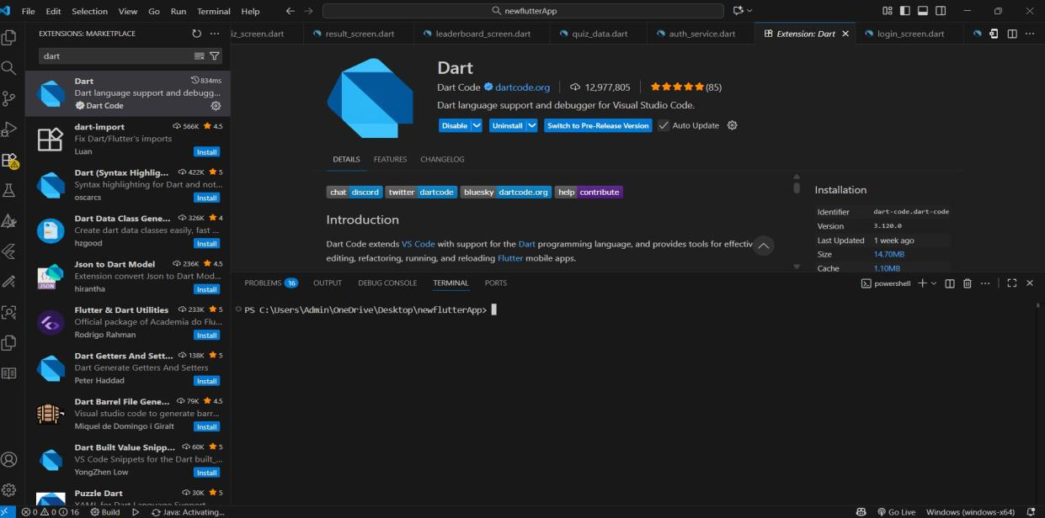
Dart and Flutter extensions installed in Visual Studio Code
Verify the Environment
flutter ‐‐version
dart ‐‐version
flutter doctor
flutter devices

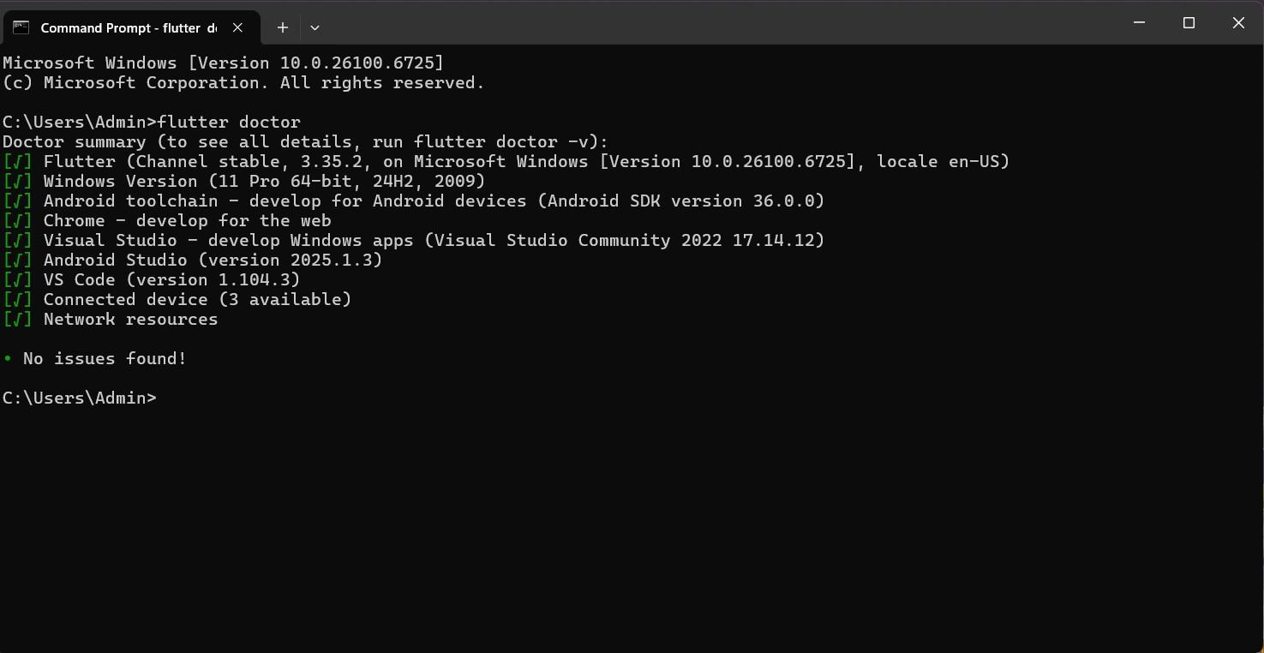
Flutter doctor output confirming the available toolchain
Environment Checks
- Confirm that the Flutter SDK and Dart versions are available.
- Resolve any missing Android SDK or platformtool warnings.
- Check that a device or emulator is listed before running the app.
- Use a clean terminal after changing PATH environment variables.
Useful Commands
flutter doctor ‐v
flutter clean
flutter pub get
flutter analyze
flutter run
The verification screenshots on this and the preceding pages document the development environment. They do not represent screens inside the Electricity Usage Tracker application.
5. Dart Programming Fundamentals Used in the Project
Dart provides the programming foundation for the Flutter application. The project uses variables, classes, lists, maps, functions, conditional statements, loops, asynchronous programming, and null safety.
Variables and Data Types
String deviceName = "Home Meter";
int userId = 101;
double tariff = 7.0;
bool isDark = true;
List<double> readings = [120.5, 145.0];
Map<String, dynamic> user = {"name": "Dileep"};
Conditional Statements
if (current < previous) {
showMessage("Invalid reading");
} else {
units = current ‐ previous;
}
Lists
Lists hold collections such as readings, chart entries, and dashboard cards.
final readings = <double>[120.5, 145.0];
for (final units in readings) {
print("Units: $units");
}
Classes and Models
class ElectricityReading {
final int? id;
final int userId;
final double previousReading;
final double currentReading;
final double units;
final double billAmount;
final String date;
ElectricityReading({
this.id,
required this.userId,
required this.previousReading,
required this.currentReading,
required this.units,
required this.billAmount,
required this.date,
});
Map<String, dynamic> toMap() => {
"id": id,
"user_id": userId,
"previous_reading": previousReading,
"current_reading": currentReading,
"units": units,
"bill_amount": billAmount,
"date": date,
};
}
Asynchronous Programming
Database operations are asynchronous so that the interface remains responsive while SQLite reads or
writes data.
Future<List<ElectricityReading>> loadReadings(int userId) async { final db = await DatabaseService.instance.database;
final rows = await db.query(
"readings",
where: "user_id = ?",
whereArgs: [userId],
orderBy: "id DESC",
);
return rows.map(ElectricityReading.fromMap).toList(); }
6. Creating and Configuring the Flutter Project
Creating the Application
flutter create electricity_usage_tracker
cd electricity_usage_tracker
code .
flutter run
pubspec.yaml
The pubspec declares the Flutter SDK and the packages used by the application. The current project
depends on sqflite, path, fl_chart, shared_preferences, and cupertino_icons.
dependencies:
flutter:
sdk: flutter
cupertino_icons: ^1.0.8
sqflite: ^2.4.3
path: ^1.9.1
fl_chart: ^1.2.0
shared_preferences: ^2.5.6
Main Application Entry Point
void main() {
WidgetsFlutterBinding.ensureInitialized();
runApp(const ElectricityUsageTracker());
}
class ElectricityUsageTracker extends StatefulWidget { const ElectricityUsageTracker({super.key});
@override
State<ElectricityUsageTracker> createState() =>
_ElectricityUsageTrackerState();
}
7. Electricity Usage Tracker – Case Study
The Electricity Usage Tracker is the central case study for this Flutter documentation. It is designed for
a user who wants to record meter readings, monitor consumption, understand monthly trends, and
estimate electricity costs without relying on a cloud account.
Core Features
- User registration, login, and local account storage.
- Profile viewing, personalinformation editing, and tariff configuration.
- Meterreading entry with previous and current values.
- Automatic calculation of consumed units and estimated bill.
- Usage history with singleitem deletion and clearall support.
- Monthly usage and bill charts with averages and an insight message.
- Inapp highusage alerts, reminders, and energysaving guidance.
- Light and dark themes with a persisted user preference.
- Responsive layouts for different mobile screen sizes.
- Local SQLite persistence for users, readings, and settings.
User Journey
- The user opens the splash screen and continues from the landing page.
- A new user registers with a name, email, and password.
- The user signs in and reaches the dashboard.
- The dashboard displays the latest usage, bill, and previous usage.
- The user adds a meter reading with previous and current values.
- The app calculates units and the estimated bill immediately.
- The reading is stored locally and appears in usage history.
- The user reviews monthly charts and the energy insight.
- The user checks alerts or updates the tariff in the profile.
- Logout clears the navigation stack and returns to login.

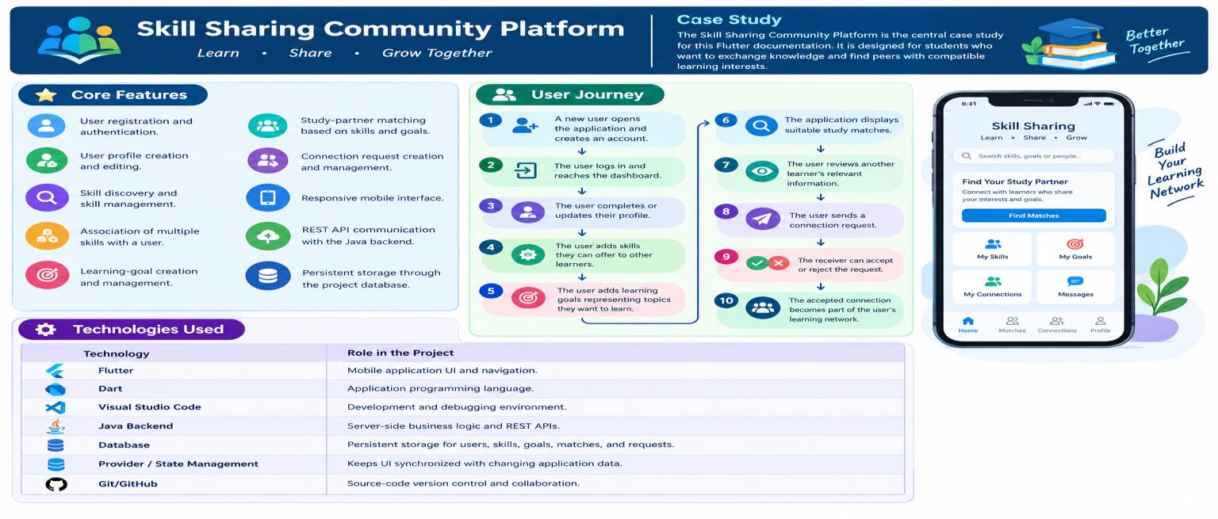
7. Electricity Usage Tracker – Case Study
Technologies Used

Technolo | Role in the Project
gy
Fl tt | C l tf UI | i ti d id t iti
u er | rosspa orm , na | v ga on, an w ge compos on.
Dart | Application language | and model classes.
sqflite | Asynchronous SQLite | access on mobile devices.
SQLite | Local storage for user | s, readings, and tariff settings.
fl_chart | Bar and line charts in | the analytics screen.
shared preferences | Persisted light or dark | theme selection.
_
Material 3 | Cards, forms, dialogs, | and responsive layout.
Visual Studio Code | Development and deb | ugging environment.
System Overview
Presentation
MaterialApp, Splash, Landing, Login/Register
Dashboard and feature screens
↓
UI state
setState, AnimationController, ThemeController ↓
Data access
DatabaseHelper (users) / DatabaseService (readings) ↓
Storage
electricity_tracker.db + electricity_usage.db
Technology and dataflow overview of the application
8. User Authentication and Profile Management
Registration creates a local account, while login verifies the entered email and password against the users table. Authentication is handled by DatabaseHelper rather than a remote service.
Registration
- All fields are required.
- The email must match a simple email pattern.
- The password must contain at least six characters.
- The password and confirmation must match.
- Duplicate email addresses are rejected before insertion.
Login
The login screen validates empty input, queries the local users table, and opens the dashboard only
when matching credentials are found.
final user = await DatabaseHelper.instance.loginUser(
email: email,
password: password,
);
if (!mounted) return;
if (user == null) {
showMessage("Invalid email or password.");
return;
}
Navigator.pushReplacement(
context,
MaterialPageRoute(
builder: (_) => DashboardScreen(
userId: user["id"] as int,
userName: user["name"] as String,
userEmail: user["email"] as String,
),
),
);

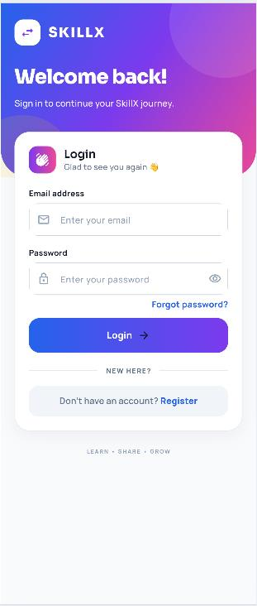
SCREENSHOT PLACEHOLDER Login screen
Replace with Electricity Usage Tracker screenshot
Profile Management
The profile screen displays the signedin user's name and email, provides access to
personalinformation editing, and manages the electricity tariff and appearance settings.
- View the current account name and email address.
- Edit the name and email through a separate screen.
- Prevent an update to an email address that already exists.
- Configure the tariff used for new reading calculations.
- Choose between the dark and light themes.
Updated profile values are returned to the dashboard so that the welcome section reflects the new name without requiring the user to sign in again.
9. Meter Reading Management
A meter reading records the previous meter value, the current meter value, the calculated units, the
tariff used, the estimated bill, the owning user, and the date. Readings are the main data source for the
dashboard, history, analytics, and alerts.
Reading Management Operations
- Add a reading for the signedin user.
- Reject nonnumeric, negative, or decreasing meter values.
- Calculate units and the estimated bill before saving.
- View readings in reverse chronological order.
- Delete one reading or clear all readings after confirmation.
Reading Card
Card(
child: ListTile(
leading: const Icon(Icons.bolt_rounded),
title: Text(
"${item.units.toStringAsFixed(1)} kWh",
),
subtitle: Text(
"${item.previousReading} → "
"${item.currentReading} kWh",
),
trailing: IconButton(
icon: const Icon(Icons.delete_outline),
onPressed: onDelete,
),
),
)
The history screen also presents the previous and current readings and the calculated bill beneath each card. Delete operations use a confirmation dialog to avoid accidental data loss.

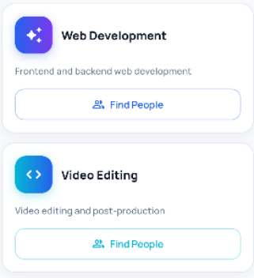
SCREENSHOT PLACEHOLDER Usage history list
Replace with Electricity Usage Tracker screenshot
Reading Ownership
Each saved reading contains a user_id value. DatabaseService filters every query by the current user,
so the history, analytics, and alert screens receive only that user's readings.
- One user can own many readings.
- Each reading belongs to exactly one user.
- Readings store their own date and calculated values.
- Deletion affects only the selected reading unless clearall is confirmed.
This is a onetomany relationship. Unlike a manytomany skill model, the application does not require a separate readingmembership table.
10. Consumption and Bill Estimation
Consumption is calculated from the difference between the current and previous meter values. The
estimated bill is the consumed units multiplied by the tariff. Both values are stored with the reading so
that historical bills remain consistent if the tariff changes later.
Calculation Operations
- Read the previous value, current value, and tariff.
- Reject empty, nonnumeric, or negative input.
- Reject a current reading below the previous reading.
- Calculate units as current minus previous.
- Calculate the estimated bill as units multiplied by tariff.
Calculation Code
void calculateUsage() {
final values = readInputs();
if (values == null) return;
setState(() {
units = values.current ‐ values.previous;
estimatedBill = units * values.rate;
});
}
Worked Example

Value | Example | Result
Previous reading | 1200 | Starting value
Current reading | 1285 | 85 units consumed
Tariff | ₹8.00 | ₹680.00 estimated bill

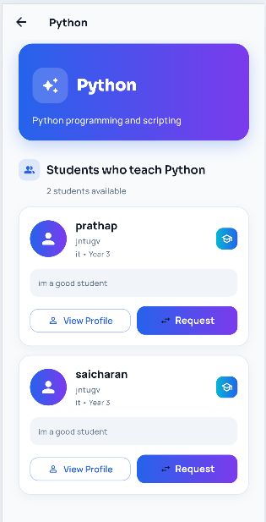
SCREENSHOT PLACEHOLDER
Bill estimate screen
Replace with Electricity Usage Tracker
screenshot
Meter Reading vs Bill Estimate

Feature | Behaviour
Purpose | A reading records actual consumption; the estimate is a quick whatif calculation.
Storage | R | eadings are saved; estimates are tempo | rary and are not inserted.
Input | R in | eading uses previous, current, and tari dependently. | ff; estimate accepts the same values
Result | B an | oth display units and a bill, but only a alytics. | saved reading affects history and
11. Usage Analytics and History
The analytics screen reads the user's saved readings, sorts them by date, and presents summary metrics,
a bar chart for monthly consumption, a line chart for bill amounts, and a short insight based on the
latest two readings.
Summary Metrics
- Average units across all saved readings.
- Average estimated bill across all saved readings.
- Highestusage reading and its date.
- Latestversusprevious usage insight.
Analytics Flow
- Load the current user's readings from DatabaseService.
- Sort the records by date in ascending order.
- Calculate average usage and average bill.
- Identify the highestusage reading.
- Build the usage bar chart and bill line chart.
- Compare the latest two readings for the insight.
Average Calculation
double get averageUsage {
if (readings.isEmpty) return 0;
return readings.fold<double>(
0,
(total, reading) => total + reading.units,
) /
readings.length;
}
History is separate from analytics: the history screen focuses on individual records and deletion, while analytics aggregates the same data into trends and comparisons.

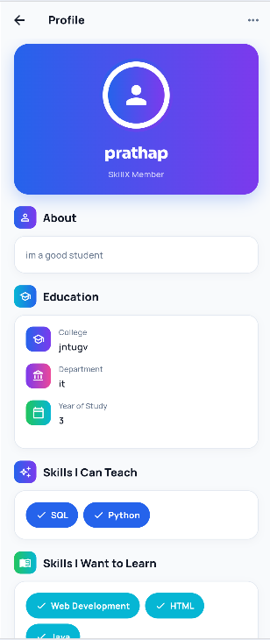
History and Chart Interpretation
The usage history screen lists every saved reading with its date, meter values, consumed units, and bill.
The analytics screen uses the same records to compare consumption over time.
Chart Interpretation
- A rising bar indicates higher consumption in a later reading.
- A falling line indicates a lower estimated bill.
- The average cards provide a quick baseline for comparison.
- The highestusage card identifies the peak record and date.
Charts are generated locally with fl_chart. No chart data is uploaded to an external analytics service.
SCREENSHOT PLACEHOLDER
Analytics screen
Replace with Electricity Usage
Tracker screenshot
Analytics screen with summary cards, charts, and insight
12. Alerts and EnergySaving Guidance
Alerts are presented inside the application. The screen loads the latest readings and compares the
newest consumed units with the previous reading. It does not schedule operatingsystem notifications
or send messages to another device.
HighUsage Check
bool get hasHighUsage {
final latest = latestReading;
final previous = previousReading;
if (latest == null || previous == null) return false;
return latest.units > previous.units;
}
Al t T
er ypes  • Highusage warning when the latest units excee • Monthly reminder to add a new meter reading. | d the previous units.
• Bill update showing the latest estimated amount.
• Energysaving tip for reducing highpower appliance use.
If fewer than two readings exist, the comparison is unavailable and the screen shows a helpful empty or caughtup state instead of a false warning.

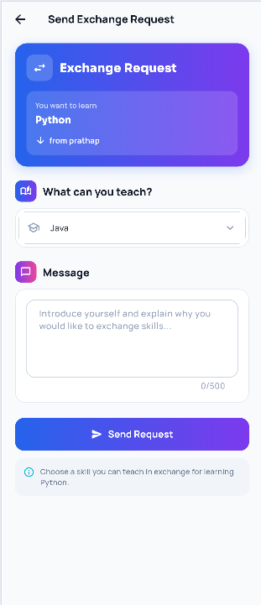
Alert Presentation
The alerts screen uses themeaware cards and a compact empty state. A refresh action reloads readings
after new data has been added.
Alert States

State | Meaning
High usage | The latest reading has more units than the previous reading.
Reminder | The user is encouraged to keep meter records current.
Bill update | The latest estimated bill is displayed.
Caught up | No warning is required, or there are too few readings to compare.
These messages are informational guidance, not electricityprovider notices. The estimated bill may differ from the actual bill because taxes, fixed charges, and slab rates are not modelled.
SCREENSHOT PLACEHOLDER
Alerts screen
Replace with Electricity
Usage Tracker screenshot
Alerts and energysaving guidance
13. Exploring Flutter Widgets in the Project
Flutter widgets are the building blocks of every screen. The project combines standard Material widgets with private builder methods and custom painters to create a consistent energythemed interface.
Important Widgets

Widget | Use in the Project
MaterialApp | Root configuration, themes, and initial route.
Scaffold | Base structure for each screen.
AppBar | Titles back action | s alerts and clearhistory action.
 | , | , ,
Text | Names, readings, u | nits, bills, and messages.
TextField | Email, password, | meter values, and tariff input.
Card / Container | Reading cards, stat | cards, and action tiles.
ListView | Dashboard section | s, history, and alerts.
Column / Row | Vertical sections a | nd paired summary cards.
Expanded | Balanced stat card | s without horizontal overflow.
SingleChildScrollView | Scrollable forms a | nd profile content.
CustomPaint | Animated energy b | ackgrounds on major screens.
AnimatedBuilder | Rebuilds animated | backgrounds efficiently.
CircularProgressIndicator | Loading and splas | h feedback.
The screens avoid fixed screen coordinates where p containers to remain readable at different widths. |  | ossible and use padding, spacing, and flexible

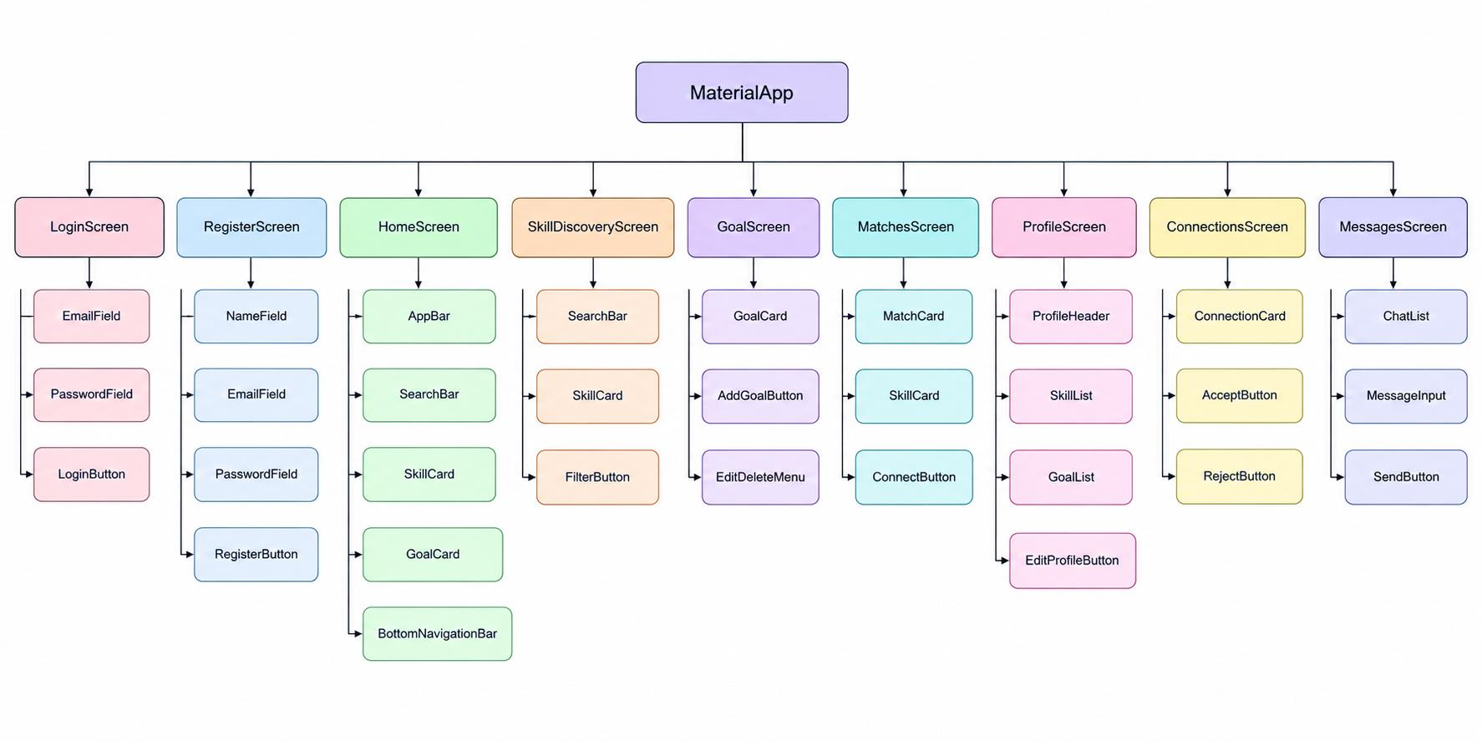
Example Widget Tree
ElectricityUsageTracker
└── MaterialApp
└── SplashScreen
└── LandingScreen
└── LoginScreen
└── DashboardScreen
├── AddReadingScreen
├── UsageHistoryScreen
├── AnalyticsScreen
├── BillEstimateScreen
├── AlertsScreen
└── ProfileScreen
DashboardScreen
└── Scaffold
├── AppBar (alerts, profile)
└── Body
└── Stack
├── CustomPaint background
└── RefreshIndicator
└── ListView
├── Welcome header
├── Main usage card
├── Stat cards
├── Quick actions
├── Comparison card
└── Latest readings
Dashboard widget composition in the Electricity Usage Tracker
The tree mirrors the source structure: the dashboard owns its animated background, refresh behaviour, and scrollable content, while feature screens are opened as separate routes.
14. Responsive UI Design
Responsive design keeps content usable across different Android screen sizes. The application relies
on flexible layout widgets, scrollable content, and themeaware spacing rather than fixed screen
coordinates.
Responsive Techniques
- SafeArea keeps content away from system bars and cutouts.
- Expanded and Flexible share horizontal space without overflow.
- ListView handles long dashboard, history, and alert content.
- SingleChildScrollView protects forms on shorter screens.
- MediaQuery.sizeOf is used for heightsensitive alert content.
- Consistent padding and spacing maintain readability.
Dashboard Layout Pattern
The dashboard uses a refreshable ListView and pairs summary cards inside a Row with Expanded
children. This lets both cards share the available width safely.
RefreshIndicator(
onRefresh: loadDashboard,
child: ListView(
padding: const EdgeInsets.fromLTRB(18, 12, 18, 28), children: [
_buildWelcomeSection(),
_buildMainUsageCard(),
Row(
children: [
Expanded(child: _statCard(...)),
const SizedBox(width: 12),
Expanded(child: _statCard(...)),
],
),
],
),
)

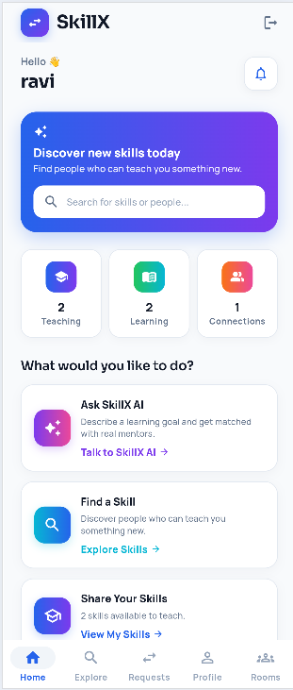
Project Application
The dashboard, history list, analytics charts, alerts, and forms must remain accessible when device
width or height changes. The interface therefore avoids depending on fixed positions for core content.
- Long content is scrollable rather than clipped.
- Card rows use Expanded children for balanced widths.
- MediaQuery is used only where a proportional height is useful.
- Forms remain usable when the keyboard reduces available space.
SCREENSHOT PLACEHOLDER
Dashboard screen
Replace with Electricity Usage
Tracker screenshot
Responsive dashboard layout
The placeholder above should be replaced with a screenshot of the Electricity Usage Tracker dashboard. The surrounding description already reflects the implemented responsive structure.

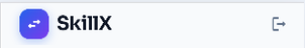
15. Navigation Between Screens
Navigation connects the authentication flow, dashboard, and feature modules. The application uses MaterialPageRoute for feature screens and replaces the login route after successful authentication.
Main Navigation Flow
SplashScreen
↓
LandingScreen
↓
LoginScreen ↔ RegisterScreen
↓
DashboardScreen
├── AddReadingScreen
├── UsageHistoryScreen
├── AnalyticsScreen
├── BillEstimateScreen
├── AlertsScreen
└── ProfileScreen
└── PersonalInformationScreen
Logout
Logout clears the authenticated navigation stack so that the user cannot return to the dashboard with
the back button.
Navigator.pushAndRemoveUntil(
context,
MaterialPageRoute(
builder: (_) => const LoginScreen(),
),
(route) => false,
);
The dashboard also reloads its readings and profile values after returning from feature screens, keeping the visible summary current.

Logout → Login Navigation stack cleared
16. Stateful and Stateless Widgets
A StatelessWidget is used when a widget does not maintain mutable state. A StatefulWidget is used
when the interface must change after a database read, form submission, theme update, or animation
tick.
Stateless Widgets
The landing screen and small reusable presentation pieces are stateless where no mutable data is
required. They receive values and callbacks through their constructors.
Stateful Widgets
- Login and registration screens maintain form and loading state.
- The dashboard maintains readings, the current name, and loading state.
- Add Reading and Bill Estimate maintain entered values and results.
- Analytics, history, alerts, and profile load and refresh local data.
setState Example
Future<void> loadDashboard() async {
try {
final data = await DatabaseService.instance.getReadings( widget.userId,
);
if (!mounted) return;
setState(() {
readings = data;
isLoading = false;
});
} catch (_) {
if (!mounted) return;
setState(() => isLoading = false);
}
}
The mounted checks prevent state updates after a screen has been removed from the widget tree.
17. State Management
The project uses local screen state for readings and forms, and a singleton ChangeNotifier for applicationwide theme state. It does not use Provider or a remote authentication session.
Why State Management Is Required
- The selected theme affects every screen in the MaterialApp.
- The dashboard must refresh after readings are added or deleted.
- Profile changes must flow back to the dashboard name.
- Loading and error states must be reflected in the interface.
Current Approach
ThemeController extends ChangeNotifier and is observed by AnimatedBuilder in main.dart. Screens observe it directly when they expose theme choices. User and reading data are reloaded from SQLite rather than stored in a global provider.
class ThemeController extends ChangeNotifier {
ThemeController._();
static final ThemeController instance = ThemeController._();
ThemeMode _themeMode = ThemeMode.dark;
ThemeMode get themeMode => _themeMode;
Future<void> loadTheme() async {
final preferences = await SharedPreferences.getInstance(); final savedTheme = preferences.getString("app_theme_mode"); _themeMode = savedTheme == "light"
? ThemeMode.light
: ThemeMode.dark;
notifyListeners();
}
Future<void> setTheme(ThemeMode mode) async {
final preferences = await SharedPreferences.getInstance(); await preferences.setString(
"app_theme_mode",
mode == ThemeMode.light ? "light" : "dark",
);
_themeMode = mode;
notifyListeners();
}
}
This approach is sufficient for a mostly local application, but a larger version would benefit from a shared session or repository layer.
18. Custom Widgets and Styling
Reusable UI patterns reduce duplication and keep the visual language consistent. The project uses
private builder methods for repeated cards and sections, custom painters for energy backgrounds, and
shared ThemeData for colours and input styles.
Reusable UI Patterns
- Stat cards for estimated bill and previous usage.
- Action cards for adding readings, viewing history, and analytics.
- Section headers for dashboard and profile groups.
- Reading cards for history entries.
- Profile option tiles for account and appearance settings.
- Custom painters for animated backgrounds.
Styling Principles
- Use the dark cyber and premium light palettes consistently.
- Use rounded cards, dialogs, and input borders.
- Keep primary actions visually distinct from destructive actions.
- Maintain readable contrast in both themes.
Theme Configuration
static final ThemeData darkTheme = ThemeData(
useMaterial3: true,
brightness: Brightness.dark,
scaffoldBackgroundColor: background,
colorScheme: const ColorScheme.dark(
primary: electricBlue,
secondary: cyberPurple,
surface: surface,
),
elevatedButtonTheme: ElevatedButtonThemeData(
style: ElevatedButton.styleFrom(
backgroundColor: electricBlue,
shape: RoundedRectangleBorder(
borderRadius: BorderRadius.circular(16),
),
),
),
);



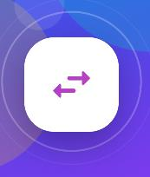
Dark Cyber Theme
#070B14 #101827 #00B7FF #8B5CF6 #FFD60A

 | Premium Light Theme
 |  | #FFFFFF #1769D2 #6741C8
# | F4F6FC | #FFFFFF #1769D2 #6741C8 | #FFC92 | 8

APPLICATION ICON
Electricity Usage Tracker
19. Forms and Validation
Forms are used for registration, login, meter readings, bill estimation, profile editing, and tariff
changes. Validation prevents invalid values from reaching SQLite and gives the user a clear message
when input cannot be accepted.
Validation Requirements

Form | Validation
Registration | Required fields, email pattern, minimum password length, matching
 | confirmation.
Login | Both email and pass | word must be entered; credentials must match.
Personal Information | Name and email are | required; email must contain @ and remain unique.
Add Reading | Numeric, nonnegat | ive values; current cannot be below previous.
Bill Estimate | Numeric, nonnegat | ive values and a positive tariff.
iff i l | fi i | h
Tar Daog | A n te amount gre | ater t an zero.
Registration Validation
final name = nameController.text.trim();
final email = emailController.text.trim();
final password = passwordController.text;
if (name.isEmpty || email.isEmpty || password.isEmpty) { _showMessage("Please fill all fields");
return;
}
if (!RegExp(r"^[^@\s]+@[^@\s]+\.[^@\s]+$")
.hasMatch(email)) {
_showMessage("Please enter a valid email address");
return;
}

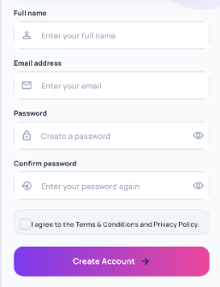
Submission
if (name.isEmpty || email.isEmpty) {
_showMessage("Please fill in all fields.");
return;
}
await DatabaseHelper.instance.insertUser(
name: name,
email: email,
password: password,
);
Clientside validation improves usability, but it is not a security boundary. This project performs validation locally and stores credentials locally as well. A production version should add password hashing and avoid storing raw passwords.
SCREENSHOT PLACEHOLDER
Registration screen
Replace with Electricity Usage Tracker screenshot
Registration form with validation feedback
The form placeholder should be replaced with a screenshot showing the actual registration fields and validation message. The current project does not use a remote backend for submission.
20. Local Data Storage with SQLite
The application persists data on the device with sqflite. There is no REST API, Java backend, or cloud
database. Account information and readings are stored in two SQLite database files.
Local Persistence
- DatabaseHelper manages the electricity_tracker.db user and reading tables.
- DatabaseService manages electricity_usage.db readings and settings.
- Database access is asynchronous and uses parameterised queries.
- Records are filtered by user_id where appropriate.
- The tariff is stored in a settings row with id 1.
Database Files
File | Contents
electricity_tracker.db | users and | a legacy readings table used by DatabaseHelper.
electricity_usage.db | readings | and settings used by the dashboard and feature screens.
Database Initialisation
Future<Database> _initDatabase() async {  final databasePath = await getDatabasesPath( final path = join( |  | );
databasePath,
"electricity_usage.db",
);
return openDatabase(
path,
version: 3,
onCreate: _createDatabase,
onUpgrade: _upgradeDatabase,
);
}
Data Access Layering
Widget or screen action
↓
setState / ThemeController
↓
DatabaseHelper or DatabaseService
↓
sqflite query, insert, update, or delete
↓
SQLite file on the device
↓
Dart model
↓
Updated interface
Error Handling
- Show a loading indicator while asynchronous work is running.
- Catch database failures and avoid leaving the screen stuck in loading state.
- Display a short, meaningful message instead of a raw exception.
- Refresh the visible data only after a successful operation.
- Use confirmation dialogs before destructive actions.
DatabaseHelper and DatabaseService are both singletons that cache the opened database. Screens await
their operations and update local state after the future completes.
Data Integrity Notes
- Readings are inserted with calculated units and bill values.
- Deletion is scoped to a selected id unless clearall is confirmed.
- The tariff update replaces the single settings row.
- The two database files create a maintenance risk that should be consolidated in a later version.
21. Database and Data Models
The project uses SQLite tables for users, readings, and settings. The schema is intentionally small, but
two separate data layers currently define overlapping reading information.
Database Tables

Table / File |  | Important Columns
/ t k |  | id il i | d
users racer |  | , name, ema (un que), pass | wor
readings / tracker |  | user_id, previous_reading, cur estimated_bill, date | rent_reading, units, tariff,
 |  | id i di | t di it bill t
readings / usage |  | user_ , prev ous_rea ng, cur date | ren_rea ng, un s, _amoun,
settings / usage |  | id tariff
 |  | ,
Conceptual Relationships
users 1 ─────< readings (Dat users 1 ─────< readings (Dat | abaseHelper) abaseService)
settings 1 ─── tariff (glo There is no manytomany relation | bal default: 7.0)  ship or connectionrequest model |  | in this application. A reading
belongs to one user, and the settin Model Responsibilities | gs table stores a single global tariff |  | .
- ElectricityReading carries reading values between the UI and database.
- toMap converts the model into a SQLitecompatible map.
- fromMap converts a database row back into a typed model.
- The model does not perform calculation; screens and services provide values.
Dart Model
class ElectricityReading {
final int? id;
final int userId;
final double previousReading;
final double currentReading;
final double units;
final double billAmount;
final String date;
ElectricityReading({
this.id,
required this.userId,
required this.previousReading,
required this.currentReading,
required this.units,
required this.billAmount,
required this.date,
});
Map<String, dynamic> toMap() => {
"id": id,
"user_id": userId,
"previous_reading": previousReading,
"current_reading": currentReading,
"units": units,
"bill_amount": billAmount,
"date": date,
};
}
The fromMap factory casts numeric SQLite values through num and calls toDouble, which handles
integer values returned by SQLite for wholenumber REAL columns.
Schema Improvement
- Consolidate the duplicate reading tables into one source of truth.
- Associate the tariff with a user if peruser rates are required.
- Add indexes on user_id and date for larger histories.
- Store password hashes instead of plaintext passwords.
22. Animations and User Experience
Animations are used to reinforce the energy theme and provide feedback. They are deliberately lightweight: no quizresult effects, leaderboards, or complex page transitions are required.
Suitable Animations
- Slow custompainted energy backgrounds on major screens.
- Circular progress indicators during loading and authentication.
- AnimatedContainer feedback for theme selection.
- Button and card ripple feedback for user actions.
- Smooth refresh behaviour after readings are added or deleted.
Animation Controller
late final AnimationController _animationController;
@override
void initState() {
super.initState();
_animationController = AnimationController(
vsync: this,
duration: const Duration(seconds: 11),
)..repeat();
}
AnimatedBuilder rebuilds only the custompainted background while the controller runs. The controller is disposed when the screen is removed to avoid unnecessary work.
23. Testing and Debugging
Testing should verify calculations, validation, persistence, navigation, and the visual states of each
screen. The current repository does not yet contain a complete test suite for the implemented
application.
Current Test Status

Area | Current Status
Widget test | Only the default counter test remains; it does not test this app.
Unit tests | No dedicated tests for calculation or validation.
Integration tests | No automated integration suite.
Manual testing | Requires an Android device or emulator for sqflite.
Recommended Tests
- Unittest unit and bill calculations, including invalid readings.
- Test registration email validation and duplicateemail rejection.
- Test ElectricityReading toMap and fromMap conversions.
- Widgettest login fields, reading forms, and validation messages.
- Integrationtest add reading → history → analytics → alerts.
- Replace the default widget_test.dart with applicationspecific tests.
Debugging Tools
- Flutter DevTools for widget inspection and performance checks.
- The Visual Studio Code debugger for breakpoints and stepping.
- debugPrint and console output for development diagnostics.
- flutter analyze for static analysis and lint feedback.
- Device or emulator logs for runtime and SQLite failures.
Error Handling Example
Future<void> loadAnalytics() async {
try {
final data = await DatabaseService.instance.getReadings( widget.userId,
);
data.sort((a, b) => a.date.compareTo(b.date));
if (!mounted) return;
setState(() {
readings = data;
isLoading = false;
});
} catch (_) {
if (!mounted) return;
setState(() => isLoading = false);
_showMessage("Unable to load analytics.");
}
}
The catch block stops the loading state and shows a short message. It does not expose the internal exception to the user.
24. Application Workflow
The complete workflow moves from splash and landing screens through authentication to the
dashboard, where the user can add readings, view history, analyse trends, estimate bills, check alerts,
and manage the profile.
Complete Screen Workflow
SplashScreen
↓
LandingScreen
↓
LoginScreen ↔ RegisterScreen
↓
DashboardScreen
├── AddReadingScreen
├── UsageHistoryScreen
├── AnalyticsScreen
├── BillEstimateScreen
├── AlertsScreen
└── ProfileScreen
├── PersonalInformationScreen
├── Tariff dialog
└── Logout → LoginScreen
Dashboard Responsibilities
- Provide the central starting point after authentication.
- Show the latest units, estimated bill, and previous usage.
- Open reading, history, analytics, bill, alert, and profile screens.
- Reload data after returning from a feature screen.
- Keep loading and empty states clear without duplicating feature logic.

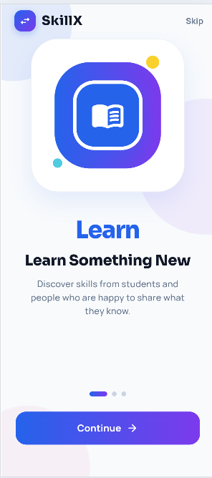
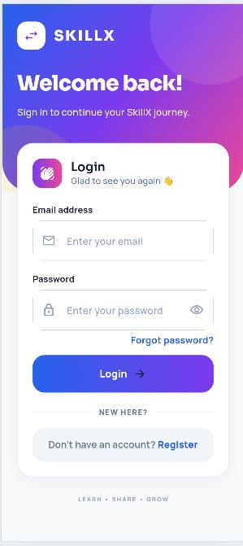
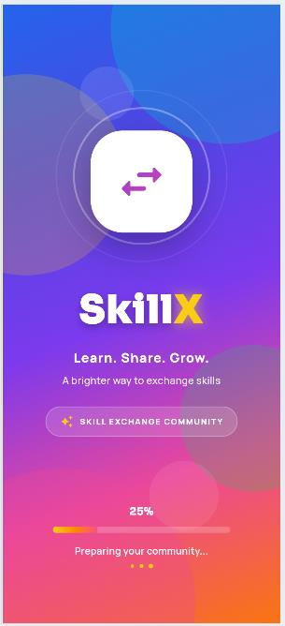
Data Flow
User Action
↓
Flutter Widget
↓
setState / ThemeController
↓
DatabaseHelper / DatabaseService
↓
SQLite query or mutation
↓
Dart Model
↓
Updated UI
Application Screens

SCREENSHOT PLACEHOLDER | SCREENSHOT PLACEHOLDER | SCREENSHOT PLACEHOLDER
Splash | Landing | Login
Replace with Electricity Usage | Replace with Electricity Usage | Replace with Electricity Usage
Tracker screenshot | Tracker screenshot | Tracker screenshot
Splash, landing, and login screens

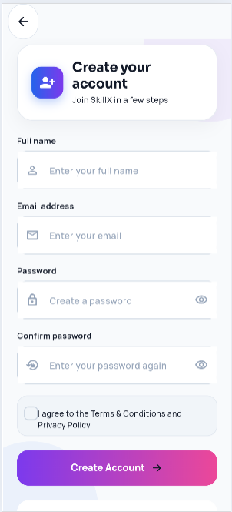
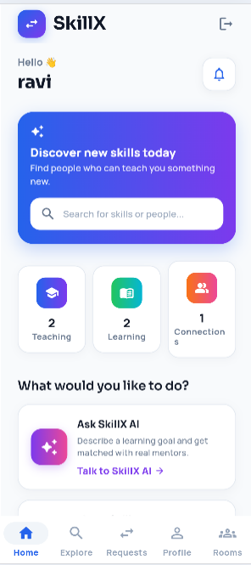
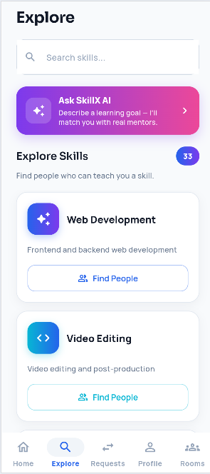
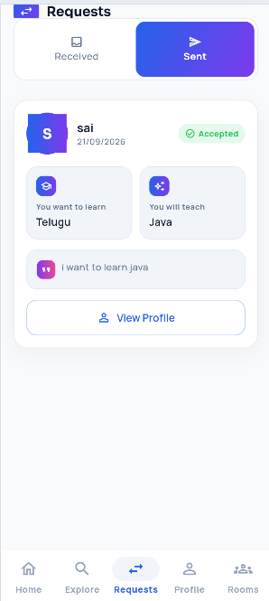

SCREENSHOT PLACEHOLDER | SCREENSHOT PLACEHOLDER
Register | Dashboard
Replace with Electricity | Replace with Electricity
Usage Tracker screenshot | Usage Tracker screenshot

SCREENSHOT PLACEHOLDER | SCREENSHOT PLACEHOLDER
Add Reading | Bill Estimate
Replace with Electricity | Replace with Electricity
Usage Tracker screenshot | Usage Tracker screenshot

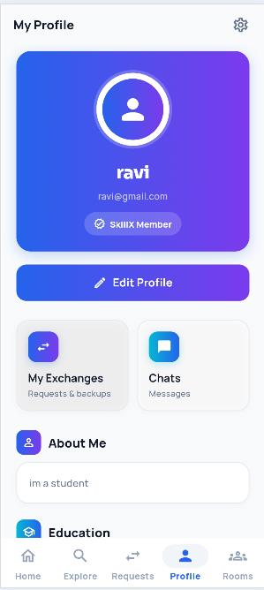
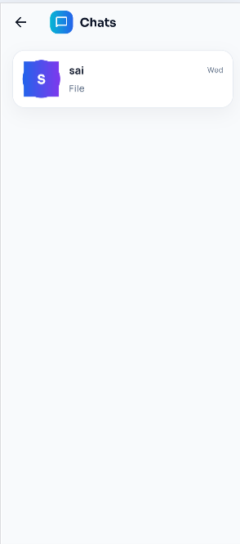
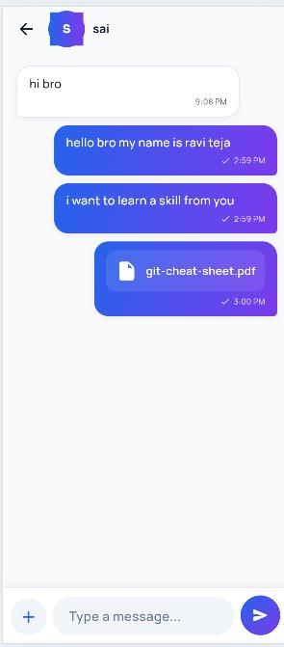
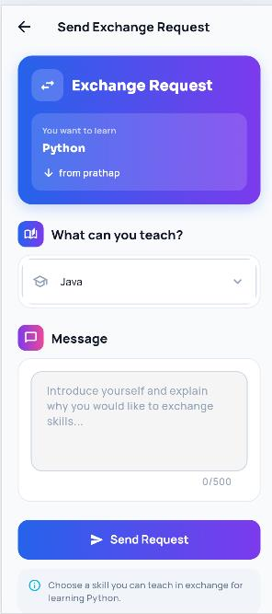

SCREENSHOT PLACEHOLDER | SCREENSHOT PLACEHOLDER
History | Analytics
Replace with Electricity | Replace with Electricity
Usage Tracker screenshot | Usage Tracker screenshot
SCREENSHOT PLACEHOLDER SCREENSHOT PLACEHOLDER Alerts Profile

Replace with Electricity | Replace with Electricity
Usage Tracker | Usage Tracker
screenshot | screenshot

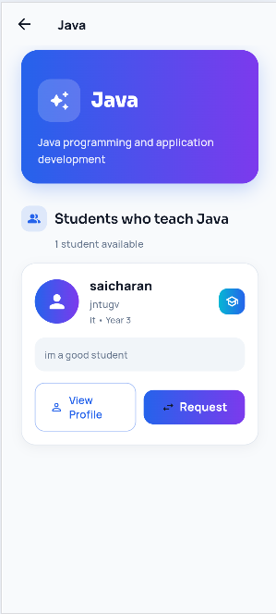
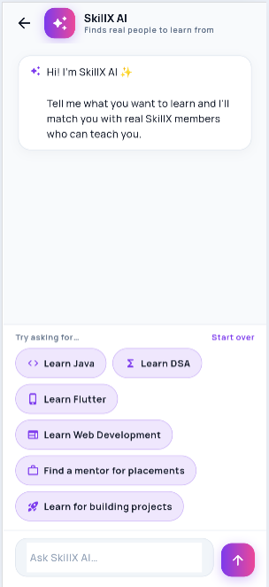
SCREENSHOT PLACEHOLDER
Personal Information
Replace with Electricity
Usage Tracker
screenshot
SCREENSHOT PLACEHOLDER
Logout
Confirmation
Replace with Electricity Usage Tracker screenshot
25. Security and Data Validation
The application stores account information and usergenerated readings on the device. Security must therefore be considered at the interface, database, and device levels. The current implementation is suitable for a local academic project but is not production hardened.
ApplicationSide Practices
- Validate required fields, email format, and password length.
- Reject negative meter values and decreasing readings.
- Confirm destructive actions before deleting data.
- Avoid showing raw database exceptions to the user.
- Use parameterised whereArgs queries rather than string concatenation.
- Clear the navigation stack on logout.
Current Limitations
- Passwords are stored as plain text in the local users table.
- There is no password hashing, encryption, or secure session token.
- There is no account recovery or serverside authentication.
- A local database can be accessed on a rooted or compromised device.
- The app does not protect against a modified client because there is no backend authority.
- The app has no cloud backup or remote access control.
Recommended Improvements
- Hash passwords with a slow, salted passwordhashing algorithm.
- Encrypt sensitive local data with platform keystore support.
- Add a shared repository layer instead of duplicate database helpers.
- Add automated validation and security regression tests.
- Remove debug prints that expose internal data before release.
26. Conclusion
The Electricity Usage Tracker demonstrates how Flutter and Dart can be used to build a practical local mobile application. The project combines authentication, profile management, meter readings, bill calculation, usage history, monthly charts, alerts, theme selection, and SQLite persistence.
The architecture separates screens, models, database services, and theme code. This structure makes the application easier to understand and extend, while also revealing maintenance issues such as duplicate reading tables and plaintext password storage.
The project also demonstrates input validation, asynchronous programming, error handling, responsive layouts, reusable UI patterns, and custompainted animation. These concepts provide a foundation for developing a more complete energymanagement application.
Final Project Summary
Area | Implementation
Frontend | Flutter and Dart | with Material 3 wid ets
 |  | g .
A th ti ti | L l i t ti | lidlt
u en ca on | oca reg s ra o | n, og n, an ogou .
Profile | Name and email | editing plus tariff configuration.
Readings | Add, list, delete, | and clear meter readings.
Calculation | Units difference | and tariffbased bill estimation.
Analytics | Average usage, | average bill, highest usage, bar and line charts.

Alerts | Inapp highusage warning, reminder, bill update, and energy tip.
Storage | sqflite databases for users, readings, and the tariff setting.
State | Local setState plus ThemeController for appearance.
Testing | Limited automated coverage; default widget test needs replacement.
Security | Local validation only; passwords are currently stored in plain text.
This documentation focuses exclusively on the Electricity Usage Tracker implementation. The original SkillX material has been replaced with this project's actual authentication, reading, calculation, analytics, alert, profile, SQLite, testing, and security behaviour.
The report also identifies clear next steps: consolidate the duplicated data layer, replace the default widget test, remove plaintext passwords, add real application screenshots, and consider a peruser tariff if the application is extended beyond a singledevice academic prototype.

